**Course 3 Starter Materials**

**Summary of project: Verdant**

The project materials you can use as you make your way through the next few courses are from a fictional mobile app called Verdant. Verdant is a mobile app for buying plants and learning about plant care. To help situate you in the design process at this stage of the program, you will be given a **user persona, user story,** and **user journey map**.

**User persona**

See the image below or open the [user persona](https://docs.google.com/presentation/d/1gesu83zwvg2yBT0rxBqxRqPNKiZ1Yg9CKWlGibwYBPY/edit?usp=sharing) in a new document.

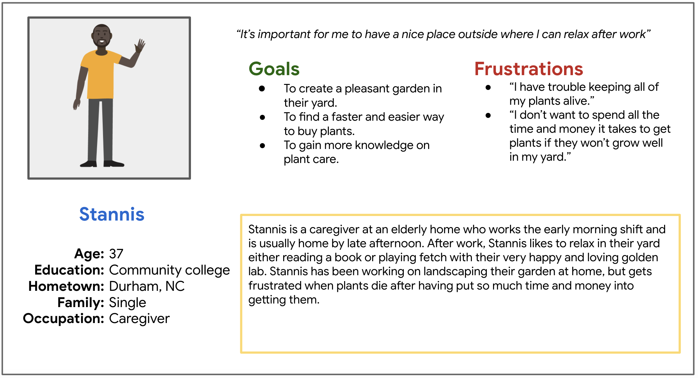

**User story**

See the image below or open the [user story](https://docs.google.com/presentation/d/1OF9okVnTKeB2M68Rnt8pazRB4XZZyav13ai4Li_97ks/edit?usp=sharing) in a new document.

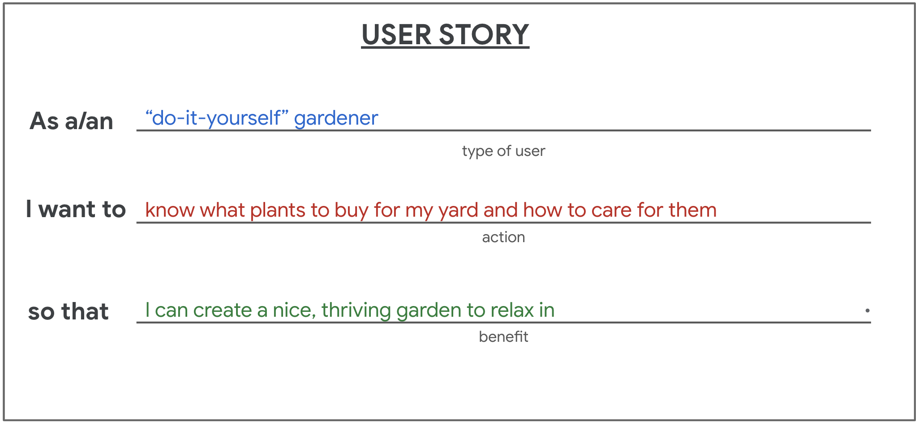

**User journey map**

See the image below or open the [user journey map](https://docs.google.com/presentation/d/1i_S6GmBaC0DVwJnvKXVKMuBlP2eujlgpvYjWTFZFaYA/edit?usp=sharing) in a new document.

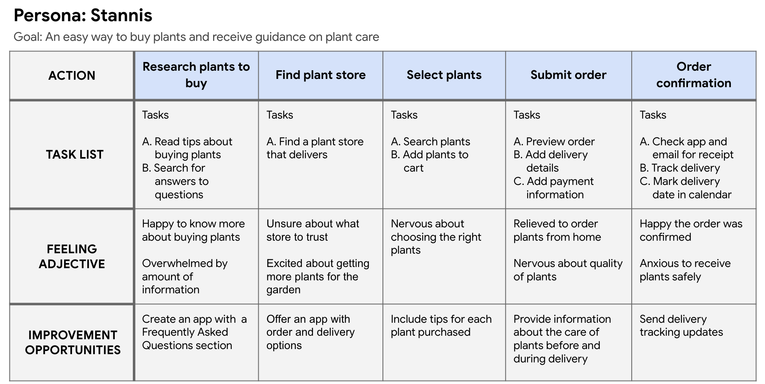

Use these materials as you move through the course. Keep in mind that if you decide to pick a new prompt for your project, you will need to go back to Courses 2-4 and complete the activities for that prompt.